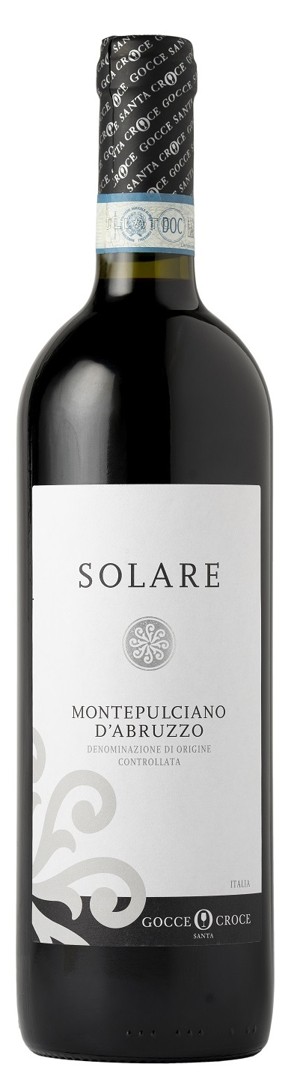
MONTEPULCIANO D’ABRUZZO DOC – SOLARE

Grape: Montepulciano 100%
Alc. Vol.%: 12,5
Vintage: 2025
Residual sugar g/l: 6,0
Total acidity g/l: 5,5
Region: Abruzzi
Production zone: Vineyards in the area of Lanciano (Chieti)
Capacity: 750ml, 1500ml

CHARACTERISTICS

Vinification: Traditional peel maceration at a controlled temperature
Aging: At least 6 months in steel tanks
Yield per ha: 14000kg
Colour: Intensive ruby red with violet reflections
Bouquet: Fruity and vigorous
Flavour: Full-bodied, fruity, with a long-lasting finish

SERVING SUGGESTIONS

Best enjoyed with starters, savoury first courses and grilled meat.
Serving temperature 18°C
TECHNICAL INFORMATION / PALLETIZING

Size 750ml:
Article Nr. V08002A
GTIN-13 bottle 8017868000655
GTIN-13 carton 8017868004387
Closure Cork
Bottles / carton 6 bottles
Pallet size 80x120cm
Cartons/layer 25
Cartons/pallet 125
Kg/carton 7,3
Kg/pallet 895

Size 1500ml:
Article Nr. V08003B
GTIN-13 bottle 8017868002451
GTIN-13 carton 8017868001133
Closure Screwcap
Bottles / carton 6 bottles
Pallet size 80x120cm
Cartons/layer 14
Cartons/pallet 56
Kg/carton 13,8
Kg/pallet 790

Contains sulphites
GMO Free
Revisione 01. 14.05.2026

